Incident Response Fundamentals - Lab Report

Date: 02/06/2026
Difficulty: Easy
Category: Defensive Security
Platform: TryHackMe

Overview

This lab discusses Incident Response and how it is carried out by security teams. It looks at how to plan and be ready for incidents and what kind of incidents to look out for. The practical element of this lab shows how an incident is declared and how it is treated to reduce further threat.

2. What I did

Incident response handles incidents from its start until its end by ensuring security measures are in place to prevent incidents, fighting incidents and minimising their impact. When a security solution finds an event or group of events to be potentially harmful, an alert is triggered. The security team will then investigate these alerts, and some may be false positives whereas others may be true positives. False positives are alerts which are flagged as suspicious but are actually safe upon review whereas true positives are alerts which are flagged as suspicious and they are suspicious and need investigated further (called incidents). Once an incident is declared, it needs to be assigned a severity level.
There are various types of incidents:

- Malware infections: Majority of incidents are associated with malware and there are various types which cause different levels of damage to a system.
- Security breaches: When unauthorised personnel get access to confidential information
- Data leaks: When confidential information is exposed to unauthorised people. Data leaks can be unintentionally done by human errors or poor configurations
- Insider attacks: Incidents from within an organisation. Someone on the inside who causes an attack with their access to resources and privileges
- Denial of service attacks: When an attacker floods the system or network with false requests which makes it unavailable to legitimate users

SANS and NIST are popular groups who contribute to cyber security and have their own frameworks in incident response. It is recommended that organisations follow these frameworks so that they have a clear plan for any incident response situation.

SANS Framework: Preparation > Identification > Containment > Eradication > Recovery > Lessons Learned
NIST framework: Preparation > Detection + Analysis > Containment, Eradication + Recovery > Post-Incident Activity

It is difficult to manually detect incidents so there are solutions in place to help security teams to identify possible incidents:

- SIEM: Security Information and Event Management solution collects all important logs in one place to identify incidents
- AV: Antivirus software detects known malicious programs in a system and does scans on your system to check its safe
- EDR: Endpoint Detection and Response is deployed on every system to protect against some high-level threats. This can also be used to contain and eradicate threats.

Having a playbook is helpful as it gives the security team the process in which to carry out successful incident response procedures in the moment. Runbooks can be used as detailed, step-by-step instructions during different incidents.

Practical

To show how this works in a practical sense, this example shows how downloading an attachment from a phishing email which has malware on it can spark an incident. My job is to investigate this incident.

I began by quarantining the hosts which has not executed the attachment yet. This shows that 3 devices downloaded the file but only 1 actually executed it.

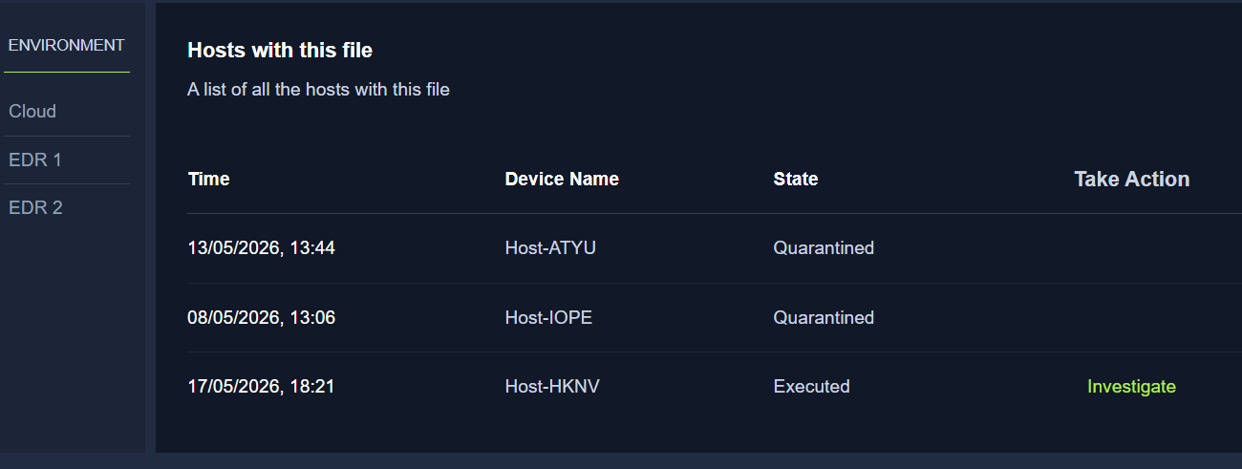

The infected device is isolated so the malware cannot spread, and the timeline is created below

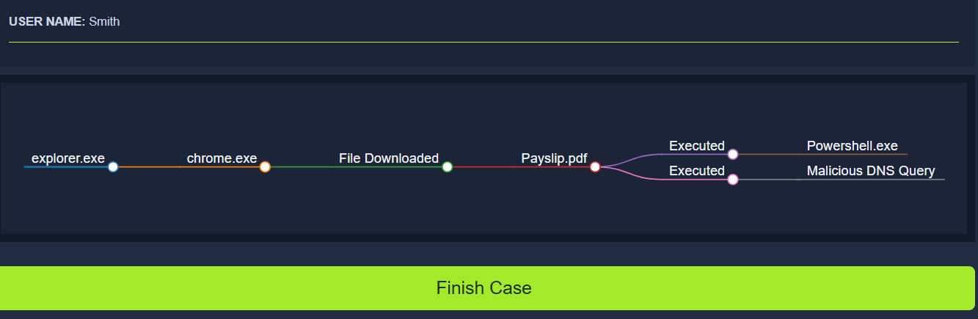

Now the case can be finished and an incident response report can be written up taking into account post-incident activity.

3. What I’ve learned

- What Incident response is
- How to respond
- Types of incidents
- The frameworks available – SANS + NIST
- Security solutions to help identification

